第二章程序的性能：35页 Q15 、Q16；
36页 Q18；P81 Q20；
39页 Q24；
54页 Q37(b)(d)(f)(g)(h)(i)(m)

Q15
The third for loop is entered n³ times. So, the total number of multiplications
is n³.

Q16
The third for loop is entered mpn times and the number of multiplications is
mpn.

Q18
The first minmax function makes zero comparisons when n < 1 and 2(n -
1) comparisons when n ≥ 1.
The second function also makes zero comparisons when n < 1. However, when
n ≥ 1, the best case number of comparisons is n - 1 and the worst case
number is 2(n - 1). The second function is expected to run faster on average.

Q20
The best case is one and the worst n + 1. In comparing the two codes, we see
that the new code has an additional assignment a[n] = x. However, the for
loop is simplified and does not include the check i < n. In a successful
search, the tradeoff is between one assignment and between 1 and n comparisons
of type i < n. In an unsuccessful search, the tradeoff is between 1 assignment
and an additional comparsion between elements of type T and n + 1
comparisons of the for i < n. For most data types T, we expect the new code
to run faster than the old one.

Q24
(a) 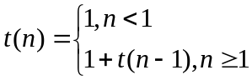 so, t(n) = 1 + t(n - 1) = 2 + t(n - 2) = … = n
(b) 4 + O(n) = O(n)
(c) 3 + O(n) = O(n)

Q37
(b) | 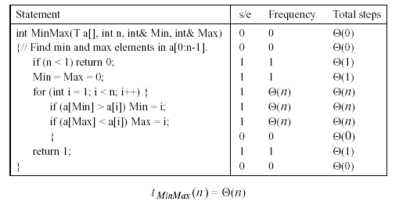
(d) | 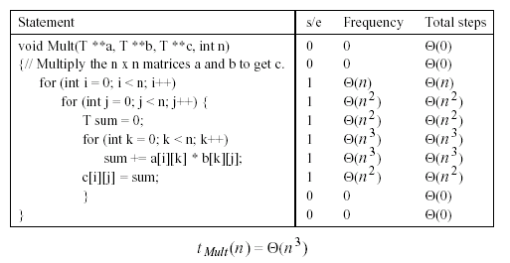
(f) | 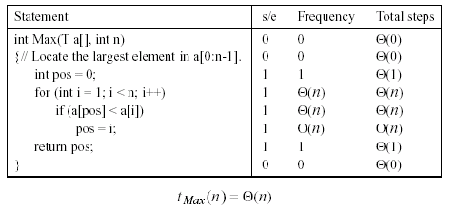
(g) | 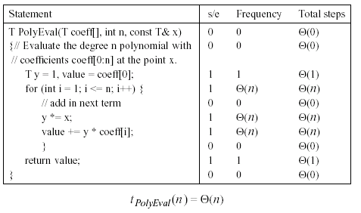
(h) | 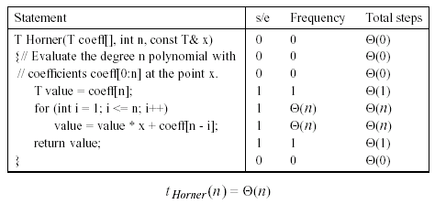
(i) | 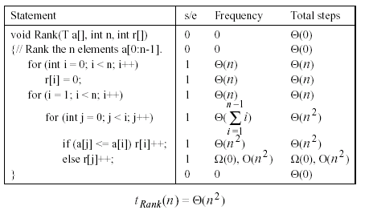
(m) | 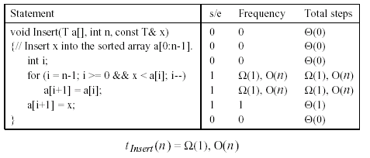
(m) | 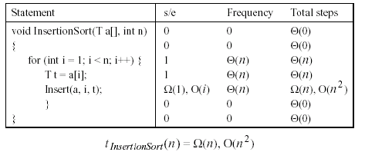

Q.27
void sort ( int E[ ], int n)
{//对数组E中的n个元素进行排序
if (n > 1) {
i = n/2;
j = n-i;
令A 包含E中的前i 个元素
令B 包含E中余下的j 个元素
sort (A , i) ;
sort (B , j) ;
merge (A, B, E, i, j) ; //把A和B合并到E
}
}
其中merge (A, B, E, i, j)的时间复杂度是O(i+j)

答：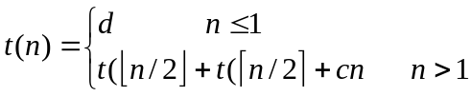
令n=2^{m},则
t(n)=2t(n/2)+cn=2[2t(n/2²)+c(n/2)]+cn=2²t(n/2²)+2cn
=……=2^{m}t(n/2^{m})+mcn=nd+cnlog₂^{n}
所以t(n)= Θ(nlog₂^{n})

